**TRINITY INTERNATIONAL SS & COLLEGE**

**Dillibazar Height, Kathmandu, Nepal**



**LAB WORK # 2: Application Package (MS-Excel)**

**(COMPUTER SCIENCE)**

**SUBMITTED BY: SUBMITTED TO:**

**NAME: Prashim Timsina**

**GRADE: XI (MC1)**

**DATE : [2079/07/27] PRAVEEN KOIRALA**

**Faculty of Computer Science**

**KATHMANDU, NEPAL**

**2022 Table of Contents**

S. No. Page No.

1. Acknowledgement I

2. Objectives II

3. Table of Contents III

4. Theoretical Background (1)

4.1 Application Package

4.1.1 Data Validation

4.1.2 Functions & Examples

4.1.3 Syntax of IF Statement

5. Work Done

5.1 Input Data Validation 2

5.2 Applying Functions 3

5.3 Applying Conditional Statements 4

6. Conclusion

7. Bibliography

8. Appendix

**2. Objective**

The main objectives of the lab work are as follows:

1. To understand input data validation in excel.
2. To use different functions in a spreadsheet.
3. To understand and apply conditional statements (IF, AND)

**3. Theoretical Background**

Data Validation: Data Validation is the process of limiting the range of input (whether string, numeric or any other) in a specific cell is known as data validation.

Functions: Functions in excel is defined as a built-in-operators that are pre-coded for further use after calling them.

Examples of Functions:

ABS function: Returns the absolute value of a number

DAVERAGE function: Returns the average of selected database entries

HARMEAN function: Returns the harmonic mean

LET function: Assigns names to calculation results

MODE function: Returns the most common value in a data set

OFFSET function: Returns a reference offset from a given reference

PERMUT function: Returns the number of permutations for a given number of objects

RAND function: Returns a random number between 0 and 1

PI function: Returns the absolute value of pi

SCAN function: Scans an array by applying a LAMBDA to each value and returns an array that has each intermediate value

Syntax of IF…ELSEIF…ELSE… Statement:

=IF(Something is True, then do something, otherwise do something else)

Page: 1

**4. Work Done**

1) Input Data Validation

The data that are being inputted in a specified cell can be validated and a validation message can also be thrown in the display screen as shown in the screenshot.

The following can be done by accessing the data tab and finding a function named data validation in the center of the screen.

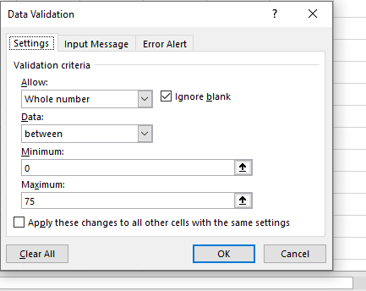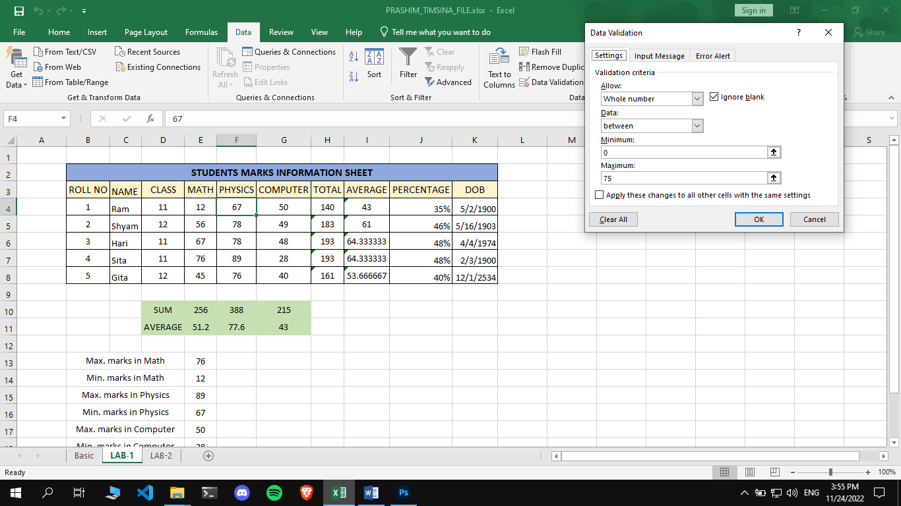

Page: 2

2) Different functions such as sum, average, count, can be used in MS-Excel by providing “=” parameter.

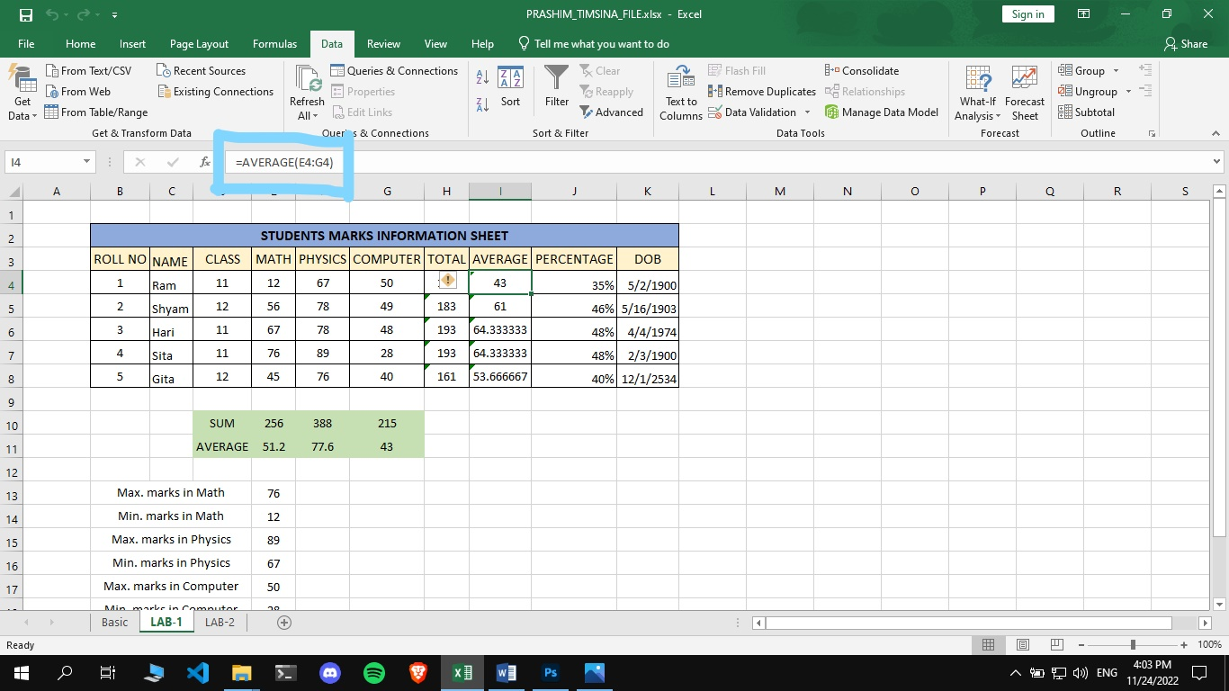

Page: 3

3) We can code conditional statements in excel in order to determine a specific type of value to be outputted on a specified cell.

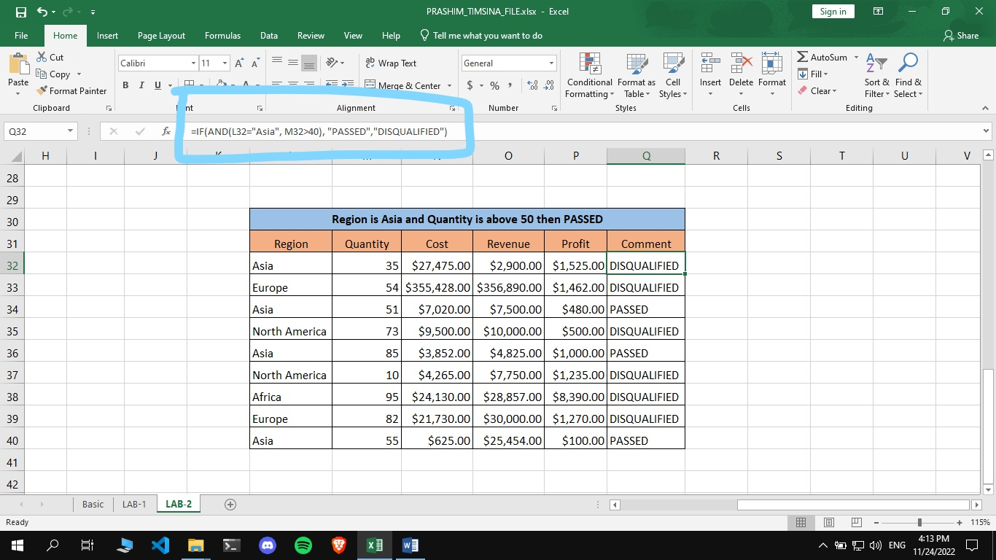

Page: 4